ECEN5283 Project 5. Object Detection
(Due on April 23, 2022)

In the class, we have discussed several Monte Carlo methods, and specifically, we have studied Jump-diffusion Markov Chain Monte Carlo (JD-MCMC) method in the context of object detection. In this project, you will implement a JD-MCMC algorithm to do object detection that is able to identify the number of objects and to locate their positions. You will be given several images each of which contains a few objects that are of identical size and appearance. Some images are smaller that are suitable for programming debugging, and others are bigger that are mainly used for algorithm evaluation. The object template will also be provided that is directly used for detecting and counting objects. Some basic Matlab functions will be provided to facilitate the programming process.

(1) function L=likelihood(Image,Object,Locations,Num)
% This function computes the likelihood of current hypotheses about the number and locations.
% Image is the gray-scale test image and Object is the object template.
% Locations is a 1*2Num vector saving the coordinates of Num objects.

(2) function drawcricle(Image,Locations,Num)
% This function draws Num circles in the image according to current location estimation.

(3) function N=clip(Locations,Mmin,Mmax)
% This function will ensure the object locations are within the image.
% “Locations” save original coordinates, Mmin and Mmax are the minimum or maximum coordinates.

(4) program create.m can be used to create a test image with certain number of objects.

(4) An useful Matlab function is POISSPDF(k,lambda), P = POISSPDF(X,LAMBDA) computes the Poisson probability density function with parameter LAMBDA at the values in X

The report of this report will be replaced by a PowerPoint file that includes the following information.
- Briefly show the algorithm implementation in terms of pseudo codes or a flowchart.
- For all given five images with a different number of targets, demonstrate your final object detection results and discuss your findings under different λ settings in the prior probability of the model order (i.e., the Poisson distribution)
- Create a video for each image to show the intermediate results of JD-MCMC inference.
- The Matlab codes of the Jump-diffusion MCMC should be given.

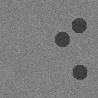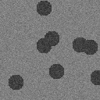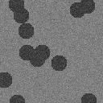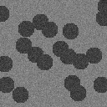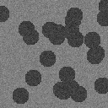
(3 objectes) (8 objectes) (12 objectes) (20 objectes) (25 objectes)

